M.Mounika(192411083)
CAS0602-CHAPTER 1(LAB OUTPUTS)
- First Palindromic String
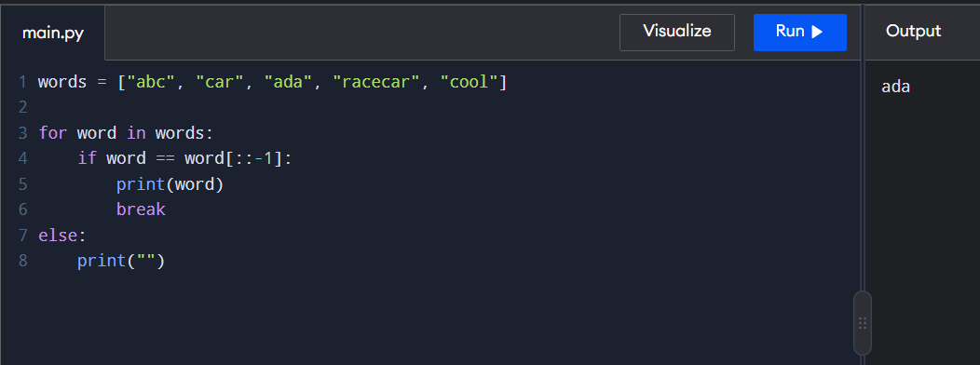

- Count Common Elements
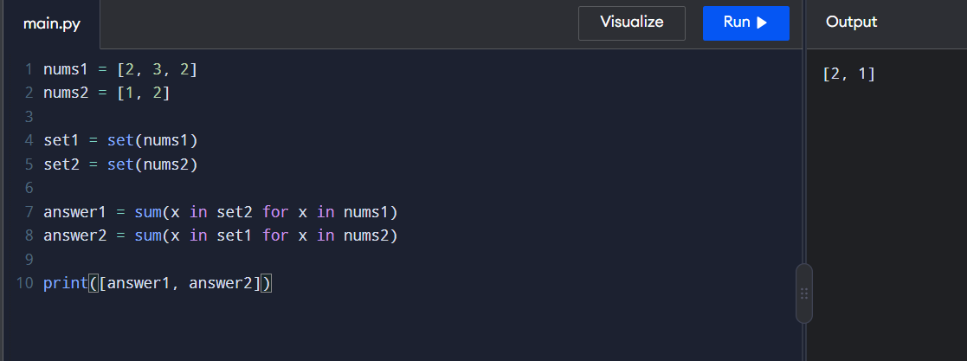

- Sum of Squares of Distinct Counts
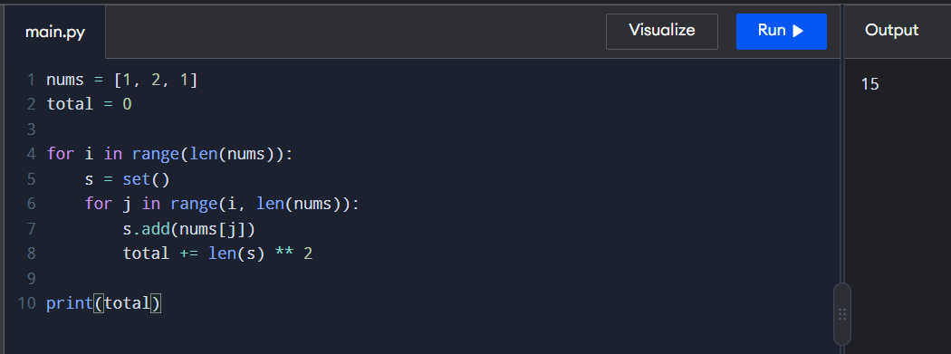

- Count Equal Pairs

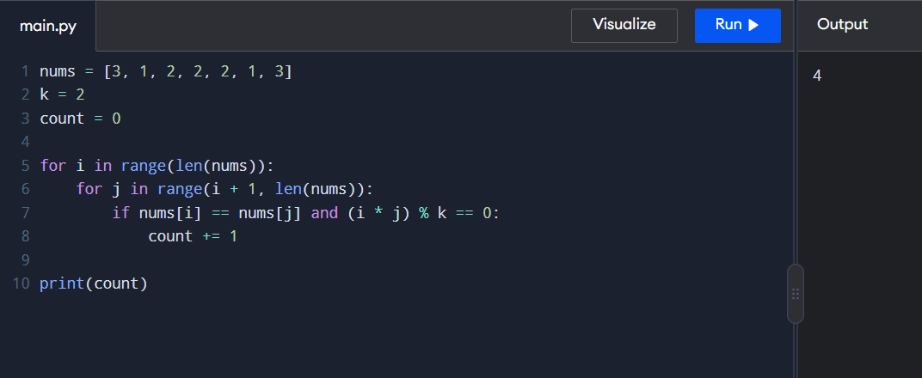

- Find Maximum Element

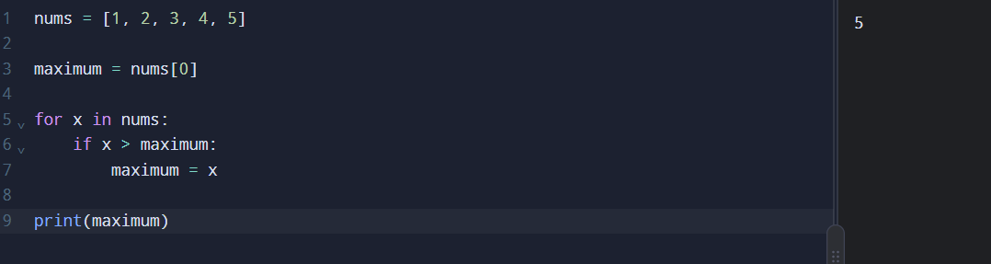

- Sort List and Find Maximum

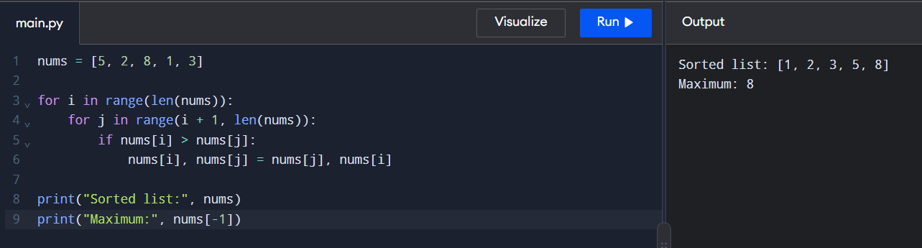

- Unique Elements

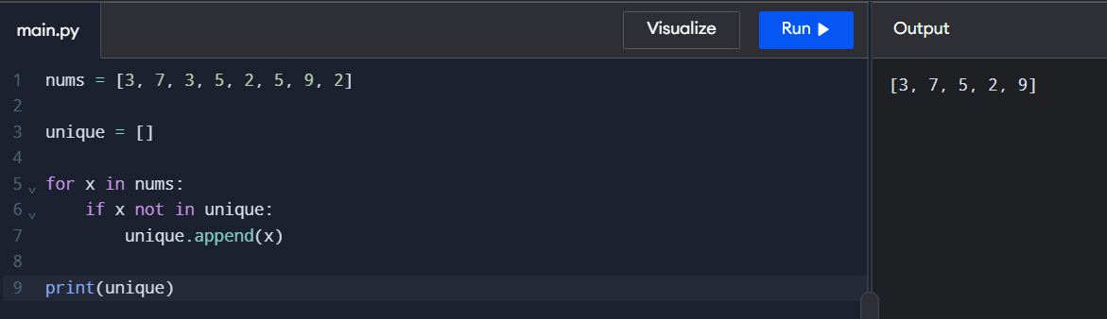
- Bubble Sort

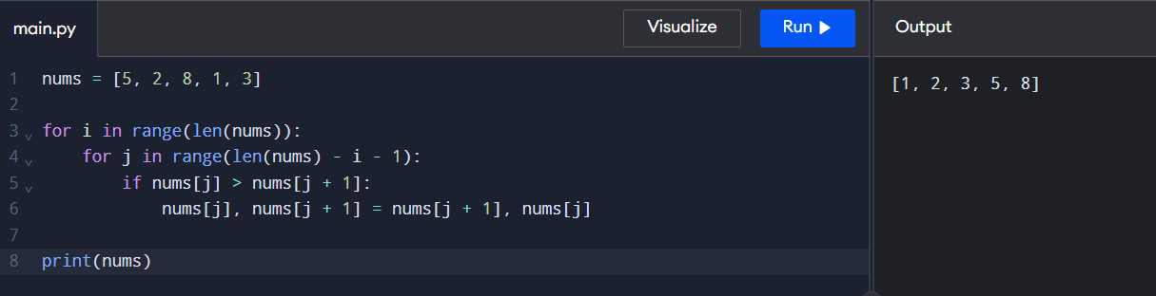

- Binary Search

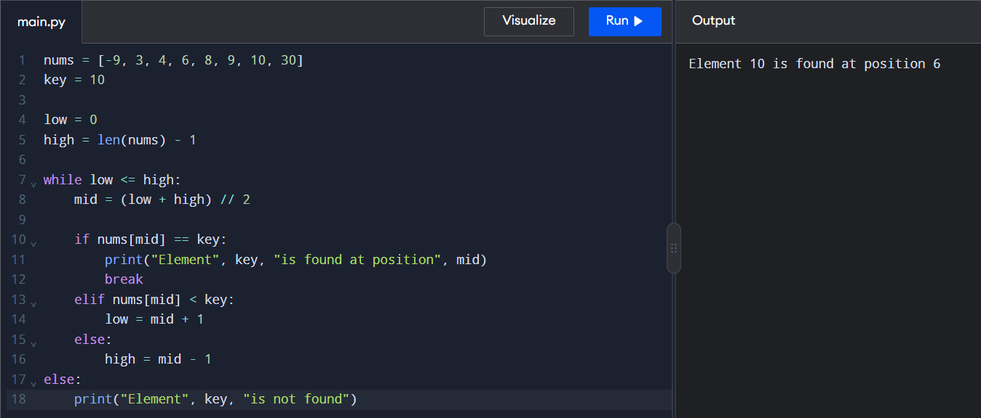

- Merge Sort
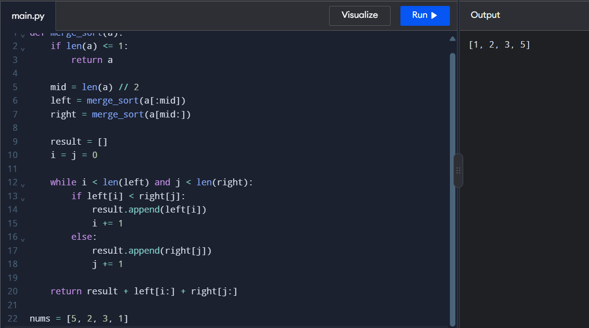

- Ball Out of Grid
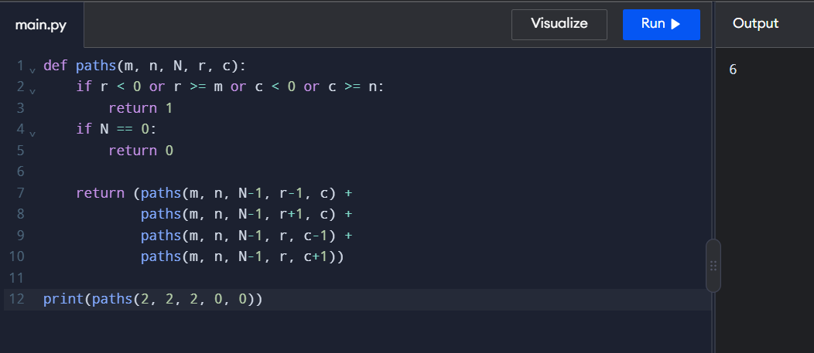

- House Robber II
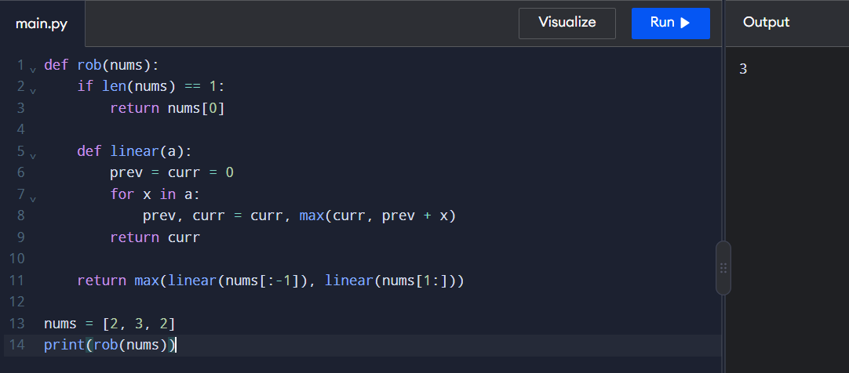
- Climbing Stairs
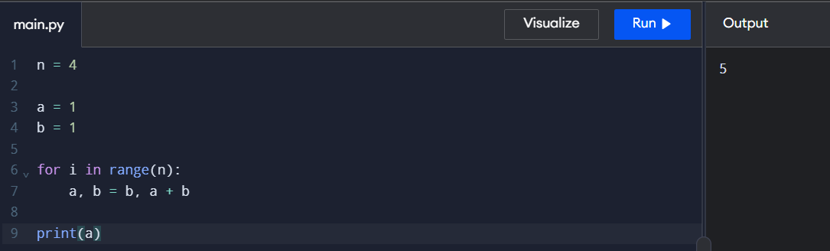

- Unique Paths

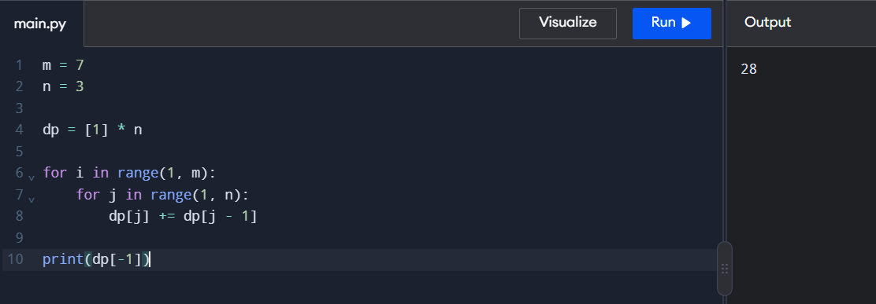

- Large Groups in a String
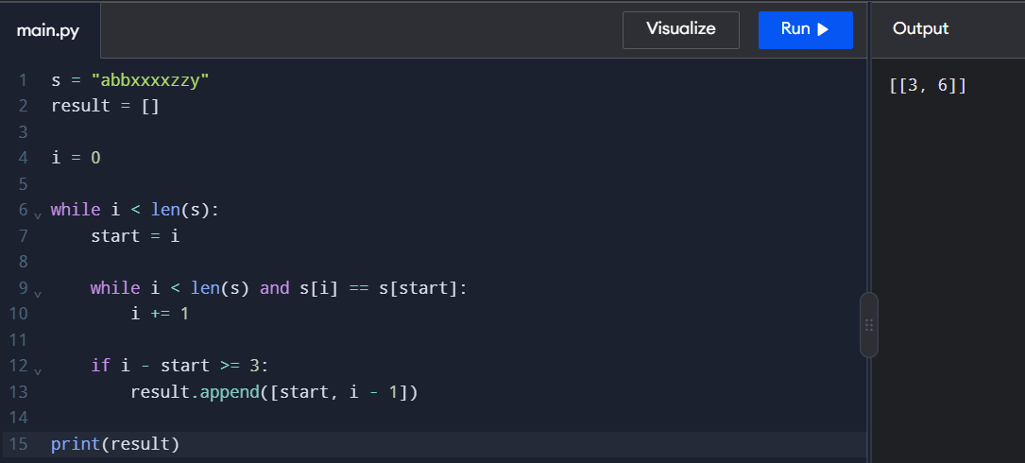
- Game of Life
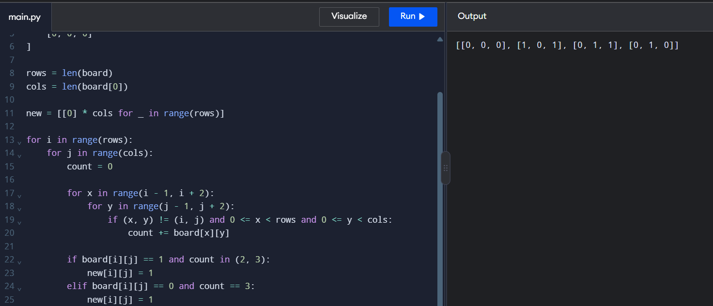

- Champagne Tower

